**PROGRAM1:**

public class Main

{

public static void main(String[] args) {

System.out.println("Hello World");

}

}

Output:

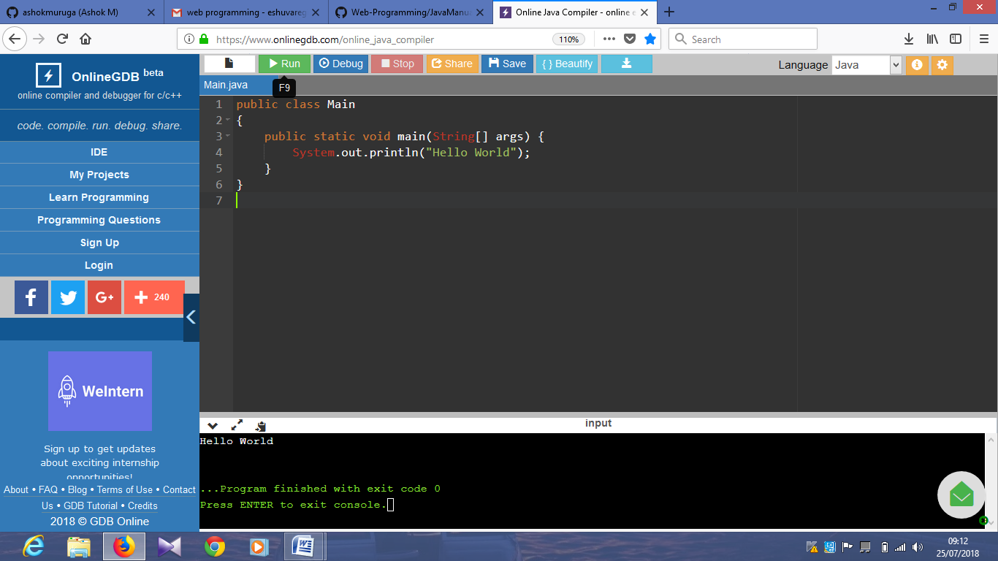

**PROGRAM2:**

class Main

{

int id;

String name;

public static void main(String args[]){

Main s1=new Main();

System.out.println(s1.id);

System.out.println(s1.name);

}

}

Output:

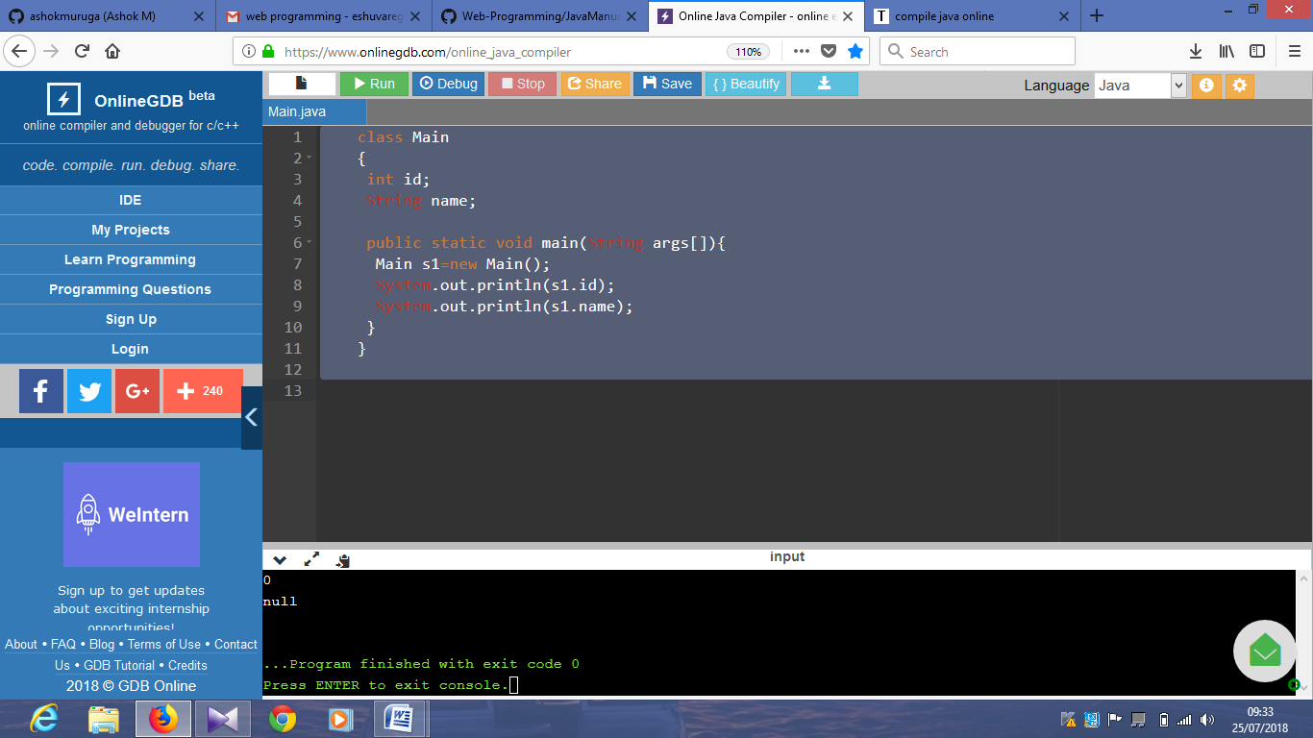

**PROGRAM3:**

class Main

{

int rollno;

String name;

void insertRecord(int r, String n){

rollno=r;

name=n;

}

void displayInformation(){System.out.println(rollno+" "+name);}

public static void main(String args[]){

Main s1=new Main();

Main s2=new Main();

s1.insertRecord(111,"Karan");

s2.insertRecord(222,"Aryan");

s1.displayInformation();

s2.displayInformation();

}

}

Output:

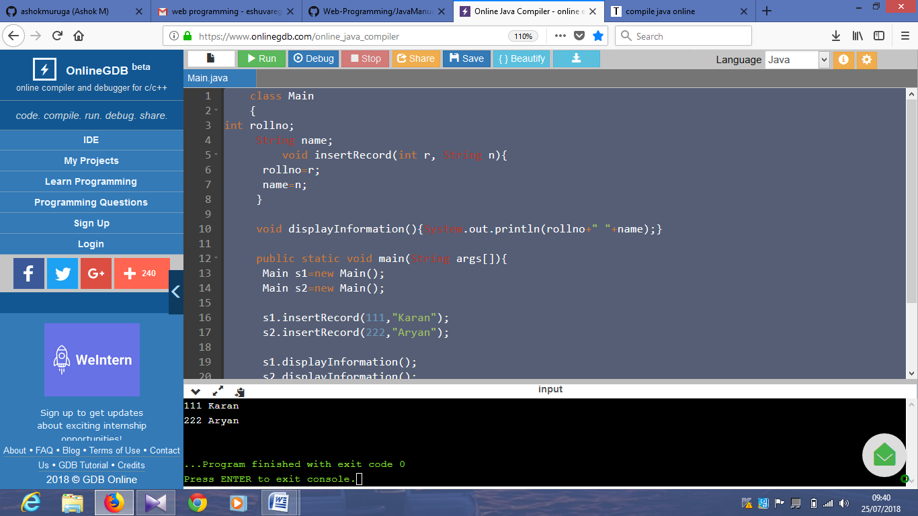

**PROGRAM4:**

class Main

{

int length;

int width;

void insert(int l,int w){

length=l;

width=w;

}

void calculateArea(){System.out.println(length*width);}

public static void main(String args[]){

Main r1=new Main();

Main r2=new Main();

r1.insert(11,5);

r2.insert(3,15);

r1.calculateArea();

r2.calculateArea();

}

}

Output:

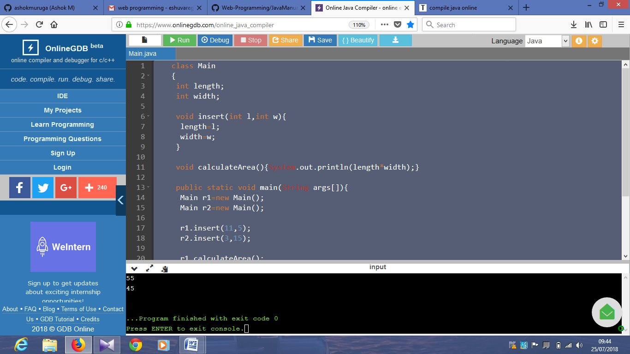

**PROGRAM5:**

class Main

{

void fact(int n){

int fact=1;

for(int i=1;i<=n;i++){

fact=fact*i;

}

System.out.println("factorial is "+fact);

}

public static void main(String args[]){

new Main().fact(5);

}

}

Output:

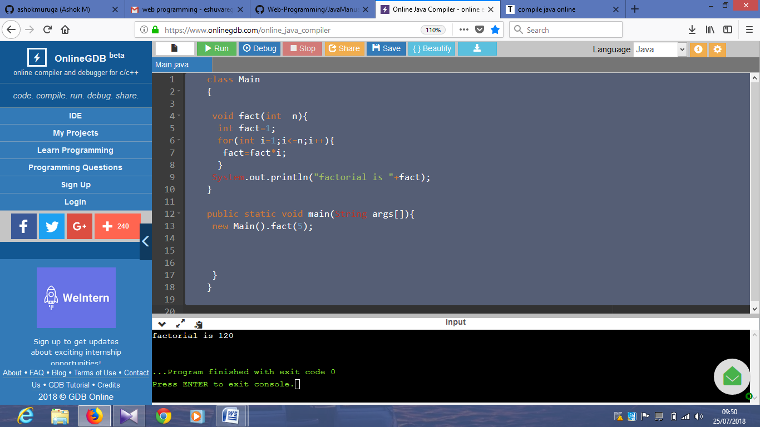

**PROGRAM6:**

class Main

{

int length;

int width;

void insert(int l,int w){

length=l;

width=w;

}

void calculateArea(){System.out.println(length*width);}

public static void main(String args[]){

Main r1=new Main(),r2=new Main();

r1.insert(11,5);

r2.insert(3,15);

r1.calculateArea();

r2.calculateArea();

}

}

Output:

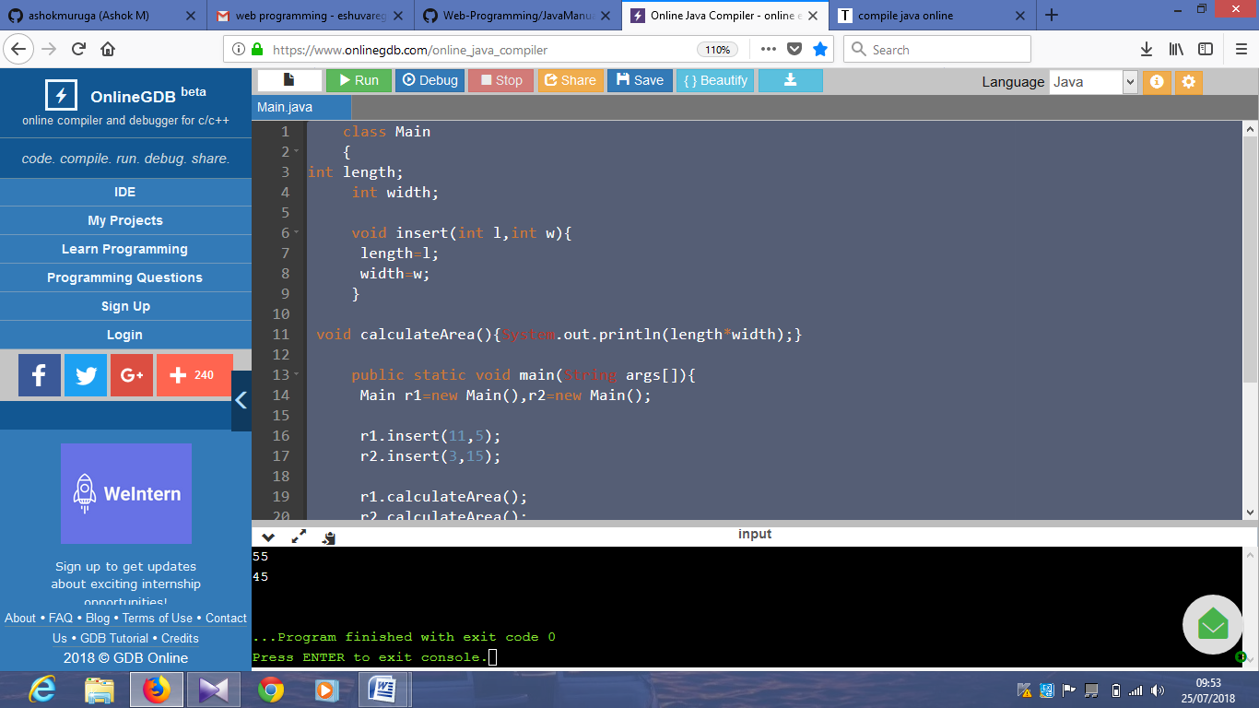

**PROGRAM7:**

class Main

{

void sum(int a,int b){System.out.println(a+b);}

void sum(int a,int b,int c){System.out.println(a+b+c);}

public static void main(String args[]){

Main obj=new Main();

obj.sum(10,10,10);

obj.sum(20,20);

}

}

Output:

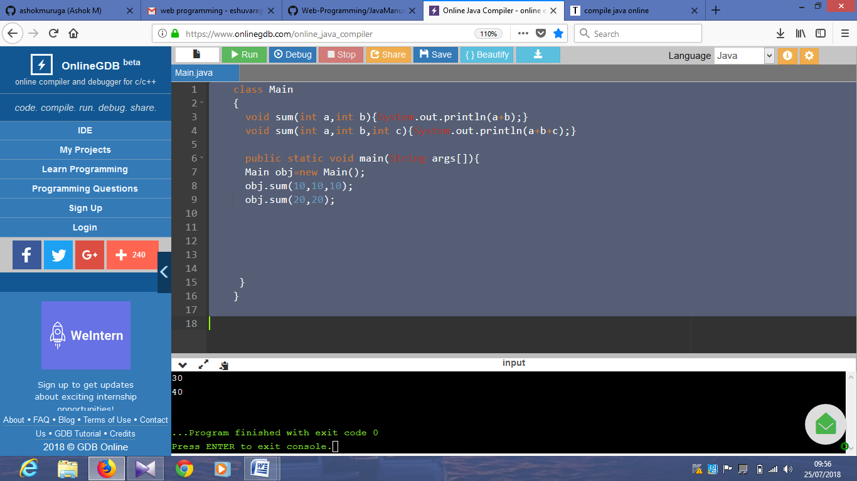

**PROGRAM8:**

class Main

{

void sum(int a,int b){System.out.println(a+b);}

void sum(double a,double b){System.out.println(a+b);}

public static void main(String args[]){

Main obj=new Main();

obj.sum(10.5,10.5);

obj.sum(20,20);

}

}

Output:

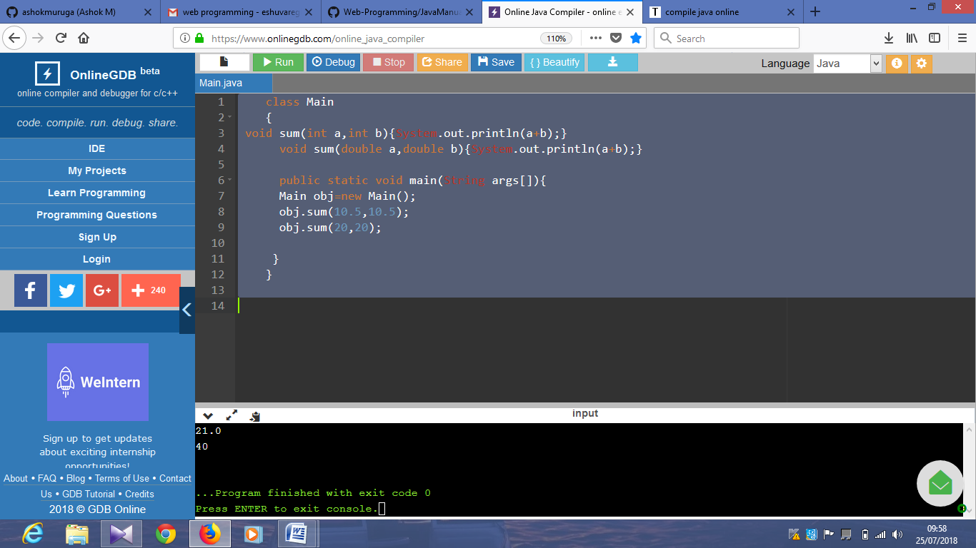

**PROGRAM9:**

class Main

{

public static void main(int a){

System.out.println(a);

}

public static void main(String args[]){

System.out.println("Main() method invoked");

Main();

}

}

**PROGRAM10:**

class Main

{

void sum(int a,long b){System.out.println(a+b);}

void sum(int a,int b,int c){System.out.println(a+b+c);}

public static void main(String args[]){

Main obj=new Main();

obj.sum(20,20);

obj.sum(20,20,20);

}

}

Output:

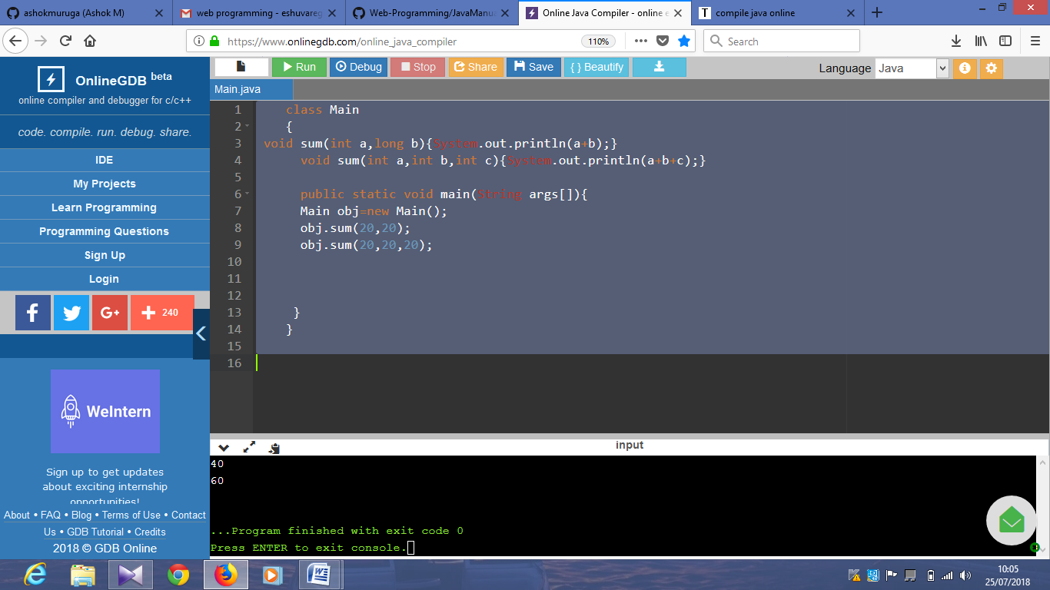

**PROGRAM11:**

class Main

{

Main(){System.out.println("Biriyani is prepared");}

public static void main(String args[]){

Main b=new Main();

}

}

Output:

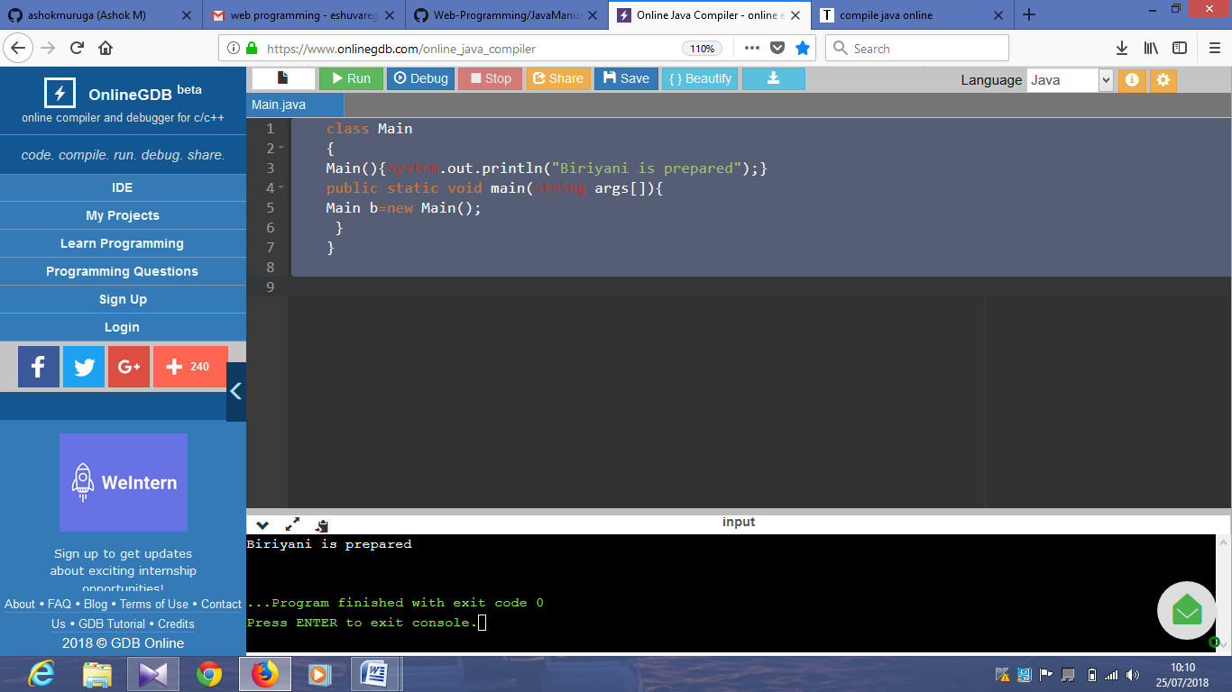

**PROGRAM12:**

class Main

{

int id;

String name;

void display(){System.out.println("001"+" "+"regina ");}

public static void main(String args[]){

Main s1=new Main();

s1.display();

}

}

Output:

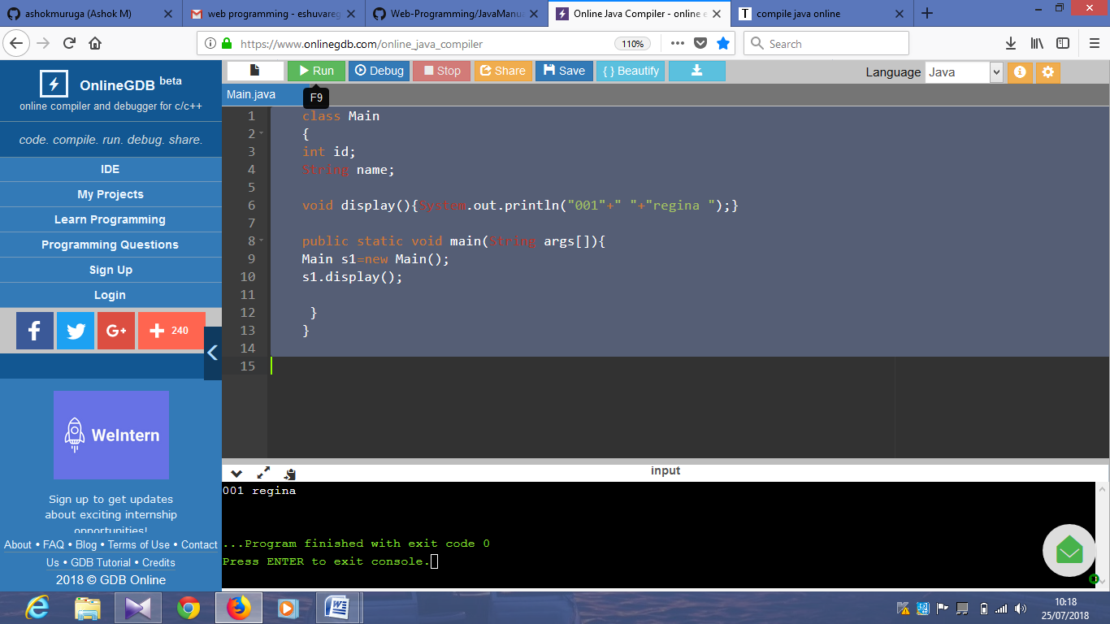

**PROGRAM13:**

class Main

{

int id;

String name;

Main(int i,String n){

id = i;

name = n;

}

void display(){System.out.println(id+" "+name);}

public static void main(String args[]){

Main s1 = new Main(100,"zoya");

Main s2 = new Main(001,"regina");

s1.display();

s2.display();

}

}

Output:

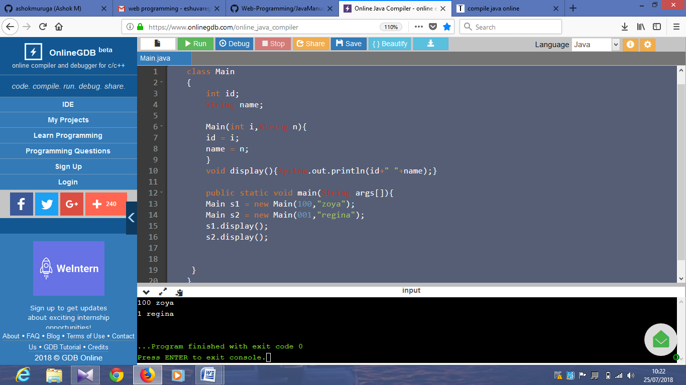

**Program 13:**

class Main{

int id;

String name;

Main(int i,String n){

id = i;

name = n;

}

Main(Main s){

id = s.id;

name =s.name;

}

void display(){System.out.println(id+" "+name);}

public static void main(String args[]){

Main s1 = new Main(111,"Karan");

Main s2 = new Main(s1);

s1.display();

s2.display();

}

}

Output:

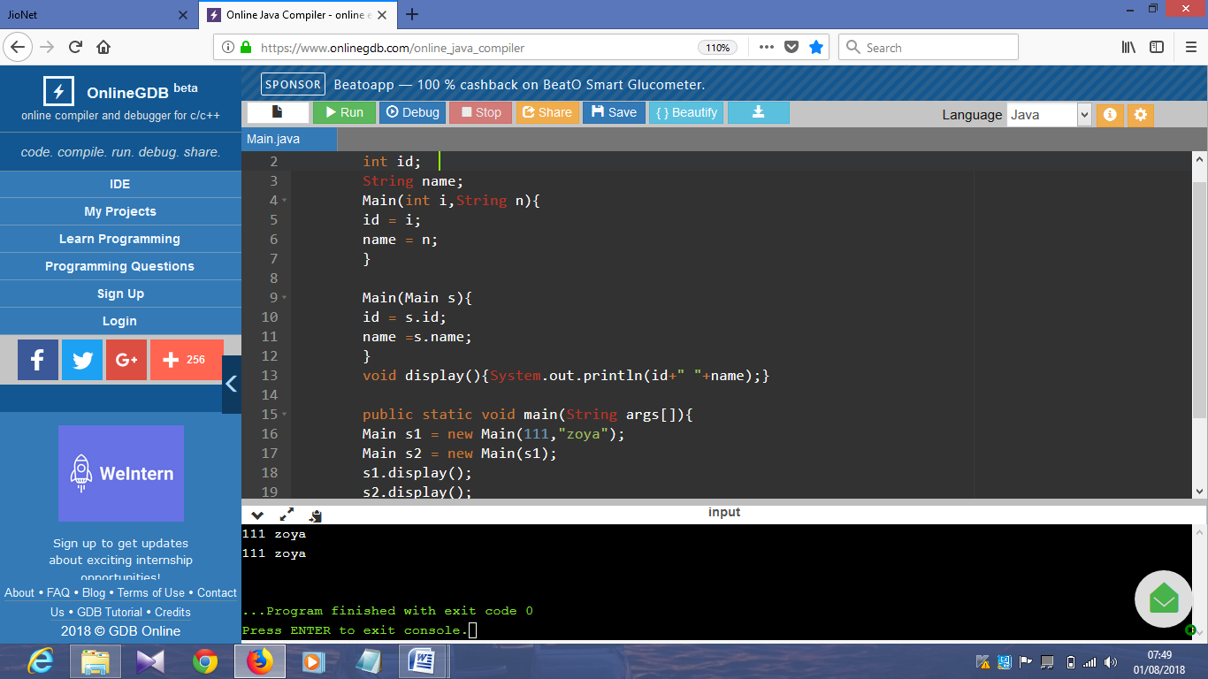

**Program 14:**

class Main{

int count=0;

Main(){

count++;

System.out.println(count);

}

public static void main(String args[]){

Main c1=new Main();

Main c2=new Main();

Main c3=new Main();

}

}

Output:

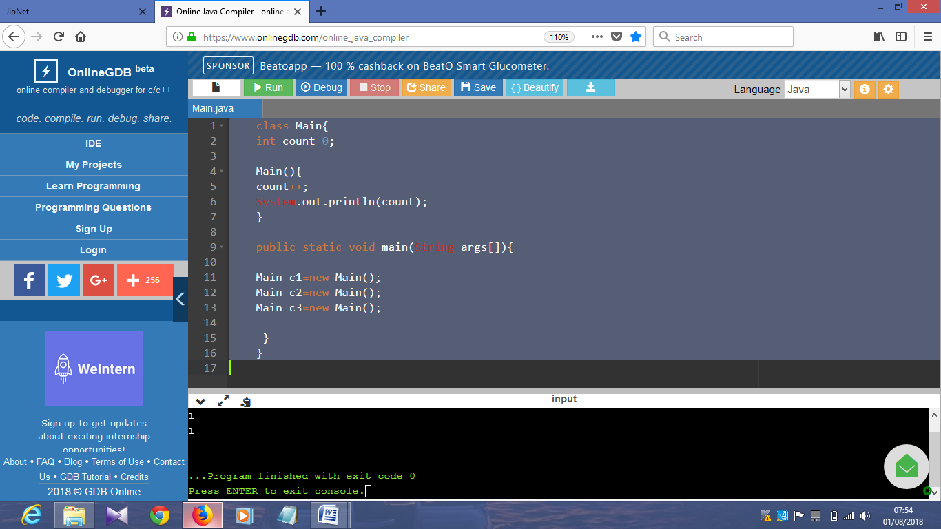

**Program 15:**

public class Main

{

static int count=0;

Main(){

count++;

System.out.println(count);

}

public static void main(String[] args) {

Main c1=new Main();

Main c2=new Main();

Main c3=new Main();

}

}

Output:

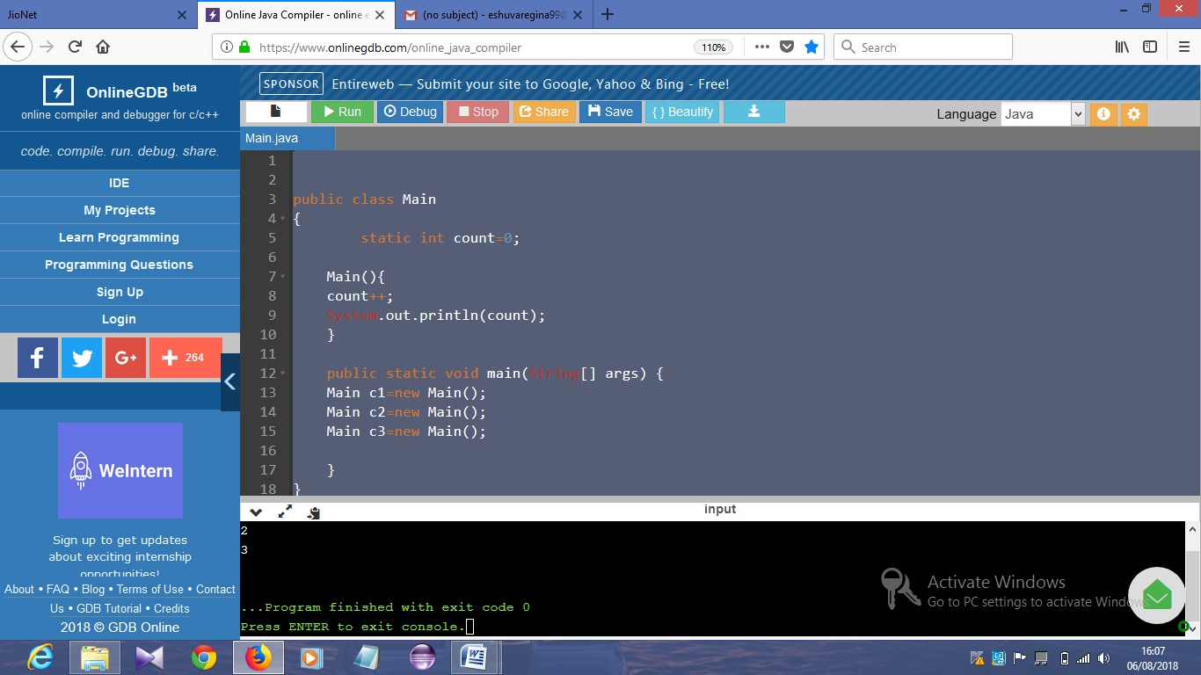

**Program 16:**

public class Main

{

int rollno;

String name;

static String college = "ITS";

static void change(){

college = "BBDIT";

}

Main(int r, String n){

rollno = r;

name = n;

}

void display (){System.out.println(rollno+" "+name+" "+college);}

public static void main(String args[]){

Main s1 = new Main (001,"harish");

Main s2 = new Main (002,"vjd");

Main s3 = new Main (003,"zoya");

s1.display();

s2.display();

s3.display();

}

}

Output:

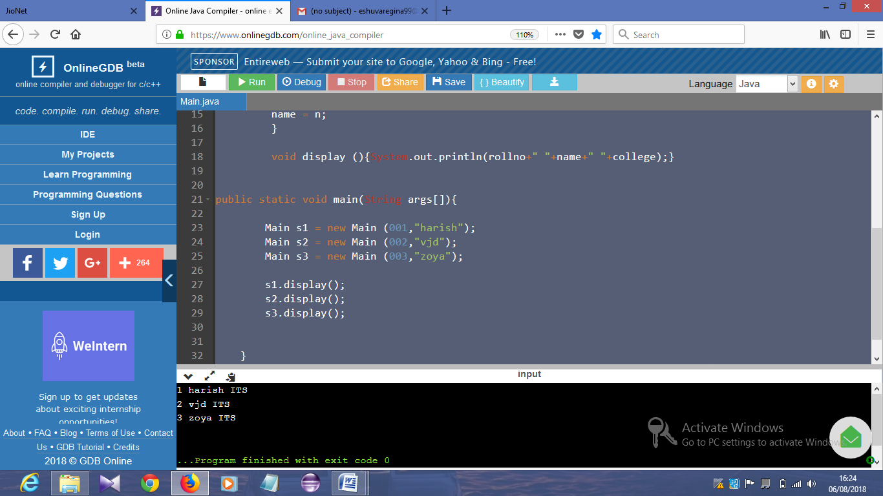

**Program 17:**

public class Main

{

int id;

String name;

Main(int id,String name){

id = id;

name = name;

}

void display(){System.out.println(id+" "+name);}

public static void main(String args[]){

Main s1 = new Main (001,"vjd");

Main s2 = new Main (002,"zoya");

s1.display();

s2.display();

}

}

Output:

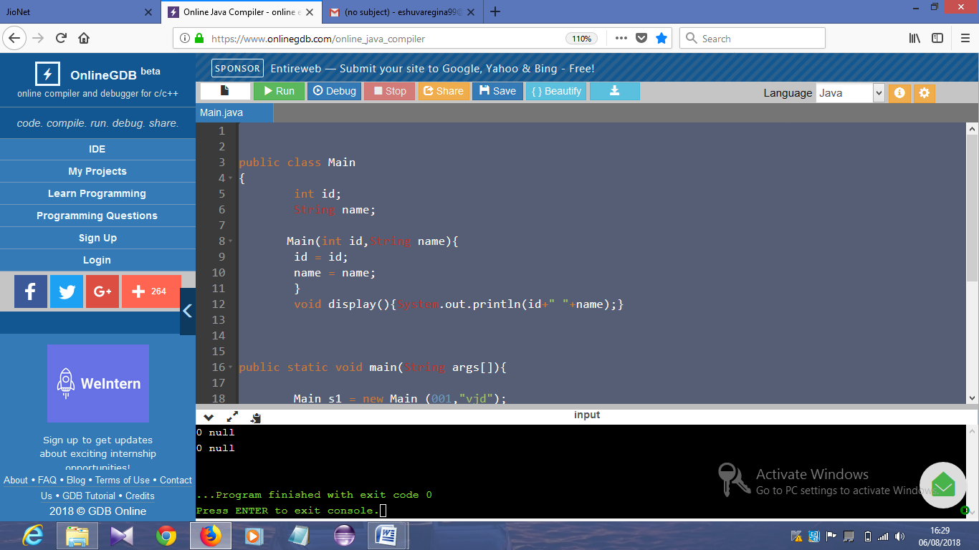

**Program 18:**

public class Main

{

int id;

String name;

Main(int id,String name){

this.id = id;

this.name = name;

}

void display(){System.out.println(id+" "+name);}

public static void main(String args[]){

Main s1 = new Main (001,"vjd");

Main s2 = new Main (002,"zoya");

s1.display();

s2.display();

}

}

Output:

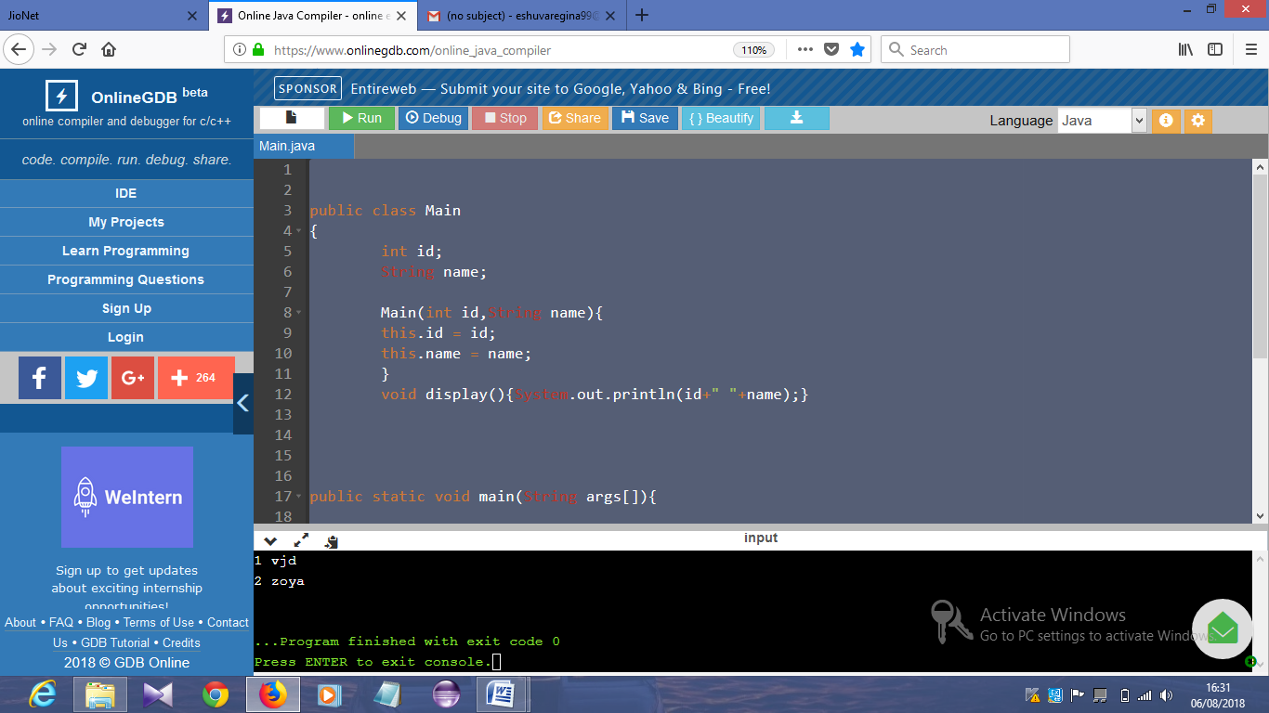

**Program 19:**

public class Main

{

int id;

String name;

Main(){System.out.println("default constructor is invoked");}

Main(int id,String name){

this ();//it is used to invoked current class constructor.

this.id = id;

this.name = name;

}

void display(){System.out.println(id+" "+name);}

public static void main(String args[]){

Main s1 = new Main (001,"vjd");

Main s2 = new Main (002,"zoya");

s1.display();

s2.display();

}

}

Output:

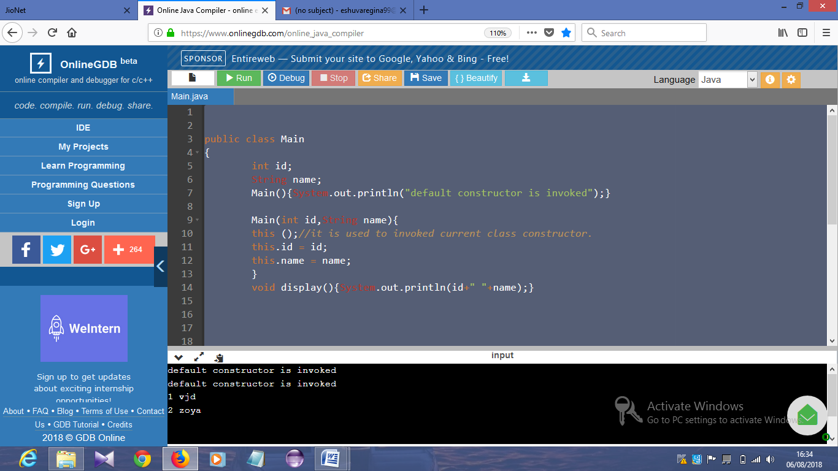

**Program 20:**

public class Main

{

int id;

String name;

String city;

Main(int id,String name){

this.id = id;

this.name = name;

}

Main(int id,String name,String city){

this(id,name);//now no need to initialize id and name

this.city=city;

}

void display(){System.out.println(id+" "+name+" "+city);}

public static void main(String args[]){

Main e1 = new Main (121,"vjd");

Main e2 = new Main (122,"zoya");

e1.display();

e2.display();

}

}

Output:

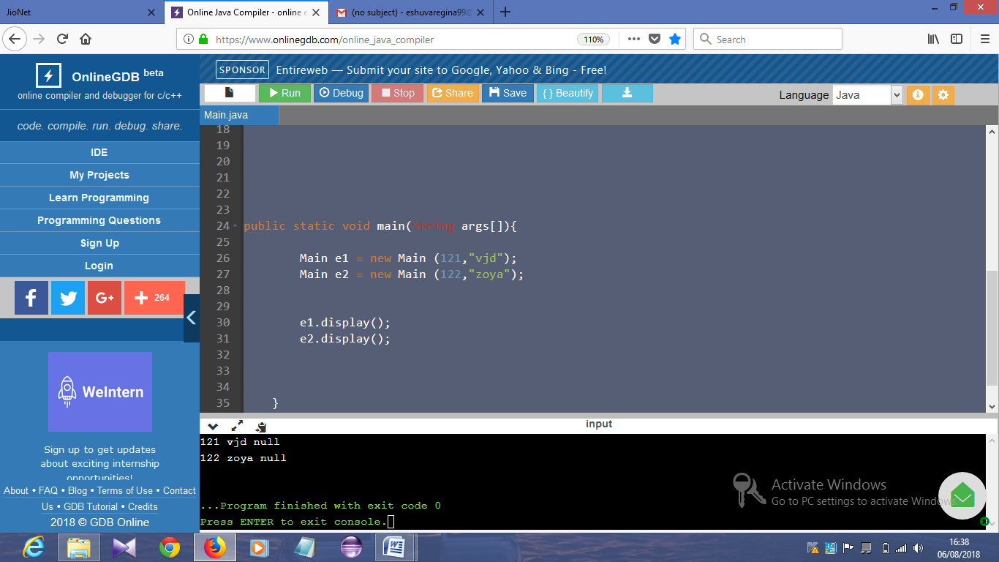

**Program 21:**

public class Main

{

void Main(){

System.out.println("method is invoked");

}

void n(){

this.Main();//no need because compiler does it for you.

}

void p(){

n();//complier will add this to invoke n() method as this.n()

}

public static void main(String args[]){

Main s1 = new Main();

s1.p();

}

}

Output:

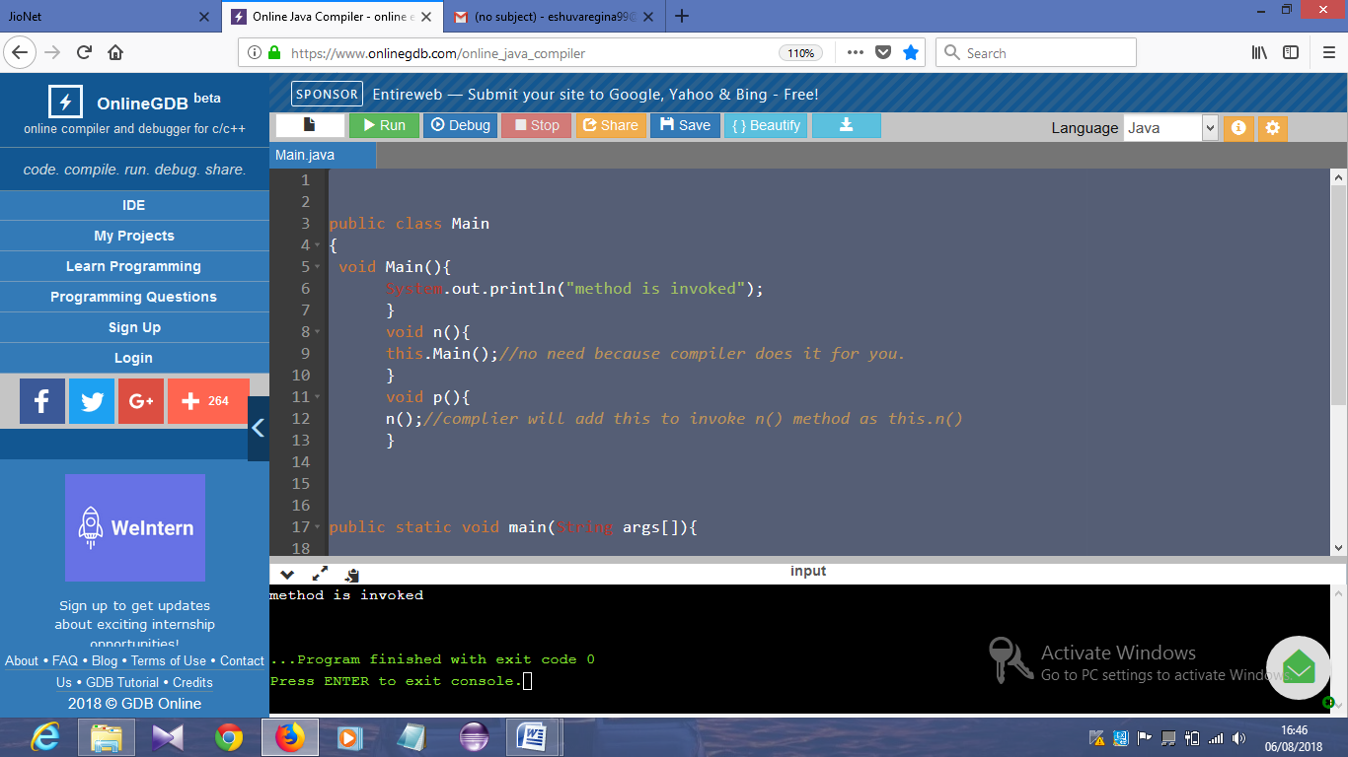

**Program 23:**

**class** B{

  A4 obj;

  B(A4 obj){

**this**.obj=obj;

  }

**void** display(){

    System.out.println(obj.data);//using data member of A4 class

  }

}

**class** A4{

**int** data=10;

  A4(){

   B b=**new** B(**this**);

   b.display();

  }

**public** **static** **void** main(String args[]){

   A4 a=**new** A4();

  }

}

Output:

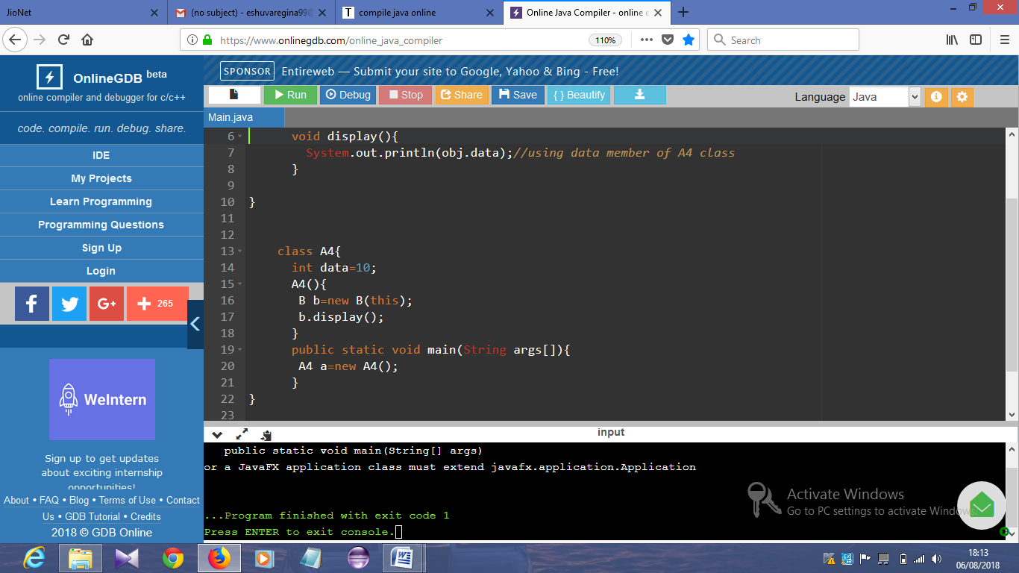

**Program 24:**

public class Main

{

Main getA(){

return this;

}

void msg(){System.out.println("Hello java");}

}

class Test1{

public static void main(String[] args) {

new Main().getA().msg();

}

}

Output:

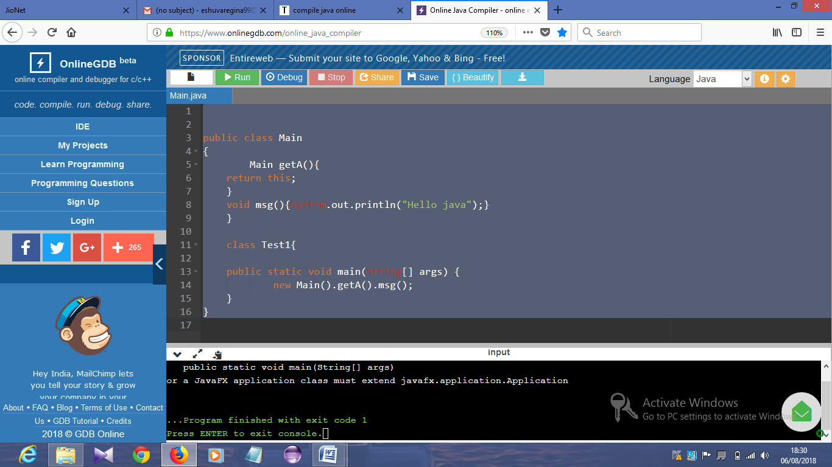

**Program 24:**

public class Main

{

float salary=40000;

}

class Programmer extends Main{

int bonus=10000;

public static void main(String[] args) {

Programmer p=new Programmer();

System.out.println("Programmer salary is:"+p.salary);

System.out.println("Bonus of Programmer is:"+p.bonus);

}

}

Output:

